Name

Mathematics Stage 4
Simplifying Expressions

Book 1 |  | Version: 260930  Feedback:  https://MrDingMaths.com
Contents
Syllabus Content 2
Like Terms 3
Adding and Subtracting Terms 5
Further Adding and Subtracting Terms 14
Multiplying Terms 17
Dividing Terms: Numerical HCF 21
Dividing Terms: Algebraic HCF 24
Mixed Practice 29
Simplifying Expressions with Mixed Operations 36
Modelling with Algebra 38

Syllabus Content
MA4-ALG-C-01 generalises number properties to operate with algebraic expressions including expansion and factorisation
Extend and apply the laws and properties of arithmetic to algebraic terms and expressions
- Generalise the associative property of addition and multiplication to algebraic expressions
- Generalise the commutative property to algebraic expressions
- Identify like terms, and add and subtract them to simplify algebraic expressions
- Simplify algebraic expressions that involve multiplication and division, including simple algebraic fractions
- Simplify algebraic expressions involving mixed operations

Like Terms

- Like Terms
Like terms have the same variables with the same powers.

- Identify whether two terms are like terms
✖  $3a$ and $3x$ | ✔  $3a$ and $3a$ |  | ✔  $3ab$ and $-$ $\frac{12ba}{7}$ |  | ✖  $3a$ and $3$ |  | ✖  $3a^{2}$ and $3a$
Decide whether these pairs of terms are like terms.
- $5a$ and $5a$ |  | - $a$ and $2a$ |  | - $-3a$ and $2a$ |  | - $4a$ and $4b$
- $3a$ and $3a^{2}$ |  | - $2a^{2}$ and $7a^{2}$ |  | - $-3a^{2}$ and $7a^{2}$ |  | - $ay$ and $ya$
- $4ay$ and $5ya$ |  | - $4a^{2}y$ and $5ya^{2}$ |  | - $4a^{2}y$ and $5ay^{2}$ |  | - $5$ and $7$
Identify the like terms in these expressions.
- $3a-5b+4a$  ¯¯¯ ¯¯¯¯ |  |  |  | - $2xy+5x-4yx$  ¯¯¯ ¯¯¯¯¯
- $7f+7g-3f+3$ |  |  |  | - $3a+2b+3k+10a$
- $5e+9e+10b$ |  |  |  | - $2pq+3qp+9p+9q$
- $10n-7+2$ |  |  |  | - $14s-3y-3x+14x$
- $x+3x-x+x^{2}$ |  |  |  | - $xy+yx-xy+7xy+3yz$
- $3j^{2}k+2jk^{2}+4j^{2}k$ |  |  |  | - $7+12x+2+2y$

- Key Ideas
- Like terms have the same ……………… and same …………………

Foundation
- Decide whether the terms are like (L) or unlike (U).
- $x 2x$ L | U  L | - $2 2x$ L | U  U
- $2x 3x$ L | U  L | - $2x 2x$ L | U  L
- $2x 2y$ L | U  U | - $2x 3y$ L | U  U
- $2x 2xy$ L | U  U | - $xy yx$ L | U  L
- $xy 2yx$ L | U  L | - $x x^{2}$ L | U  U
- $xy x^{2}y$ L | U  U | - $xy^{2} x^{2}y$ L | U  U
- $xy^{2} y^{2}x$ L | U  L | - $xyz 2yxz$ L | U  L
- $5a 5b$ L | U  U | - $27 27f$ L | U  U
- $3b 4b$ L | U  L | - $8xy 9xy$ L | U  L
- $11 12$ L | U  L | - $3z^{2} 3z^{3}$ L | U  U
- $-7d 21d$ L | U  L | - $5a -5a$ L | U  L
- $e^{2} f^{2}$ L | U  U | - $3x x$ L | U  L

- In each set of three, circle the term that is unlike the other two.
- 2𝑥 2 −2𝑥  $2$ | - $x^{2} 3x^{2} 3x$  $3x$
- 3𝑏 𝑏 3  $3$ | - $-3 -10 -3t$  $-3t$
- $\frac{1}{2}y$ $\frac{1}{2}$ $y$  $$\frac{1}{2}$$ | - $6ab 7ab$ $\frac{a}{b}$  $$\frac{a}{b}$$
- $3x 3y -3x$  $3y$ | - $2b b^{2} 10b$  $b^{2}$

- Circle a set of like terms in each list, underline any other sets of like terms.
- $5-4a+2+3a$  $5, 2$ | $-4a, 3a$ | - $3r-t+5+4r-2$  $3r, 4r$ | $5,-2$
- $6ab+4a+3b-2ab$  $$6ab, -2ab$$ | - $12t-3m+5+3m-9t$  $12t, -9t$ | $-3m, 3m$
- $5yx+3xy-4+3-2$  $5yx, 3xy$ | $-4, 3, -2$ | - $4mn+6nm-3+x+7$  $4mn, 6mn$ | $-3, 7$

Adding and Subtracting Terms

- Adding and Subtracting Terms
- Simplify expressions by adding like terms.
- To simplify expressions with addition and subtraction:
- Identify the like terms.
- Add the like terms.
- An expression with no like terms is fully simplified.

- Example Simplify expressions by combining like terms
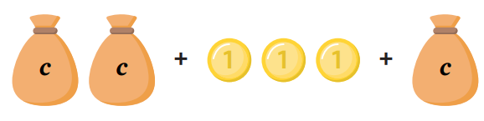  $2c+3+c$  1. ¯¯ ¯¯  2. $3c+3$ | $2xy+5x-4xy$  1. ¯¯¯ ¯¯¯¯¯  2. $-2xy+5x$

- Guided Practice
Simplify these expressions.
- $3b+4+2b$
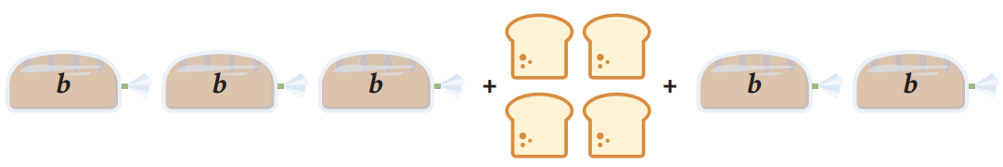

$5b+4$
- $l+5+4l+2$
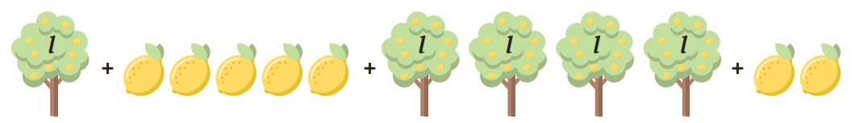

$$5l+7$$
- $3x+6-2x$  $x+6$ | - $6-7q+12$  $18-7q$
- $5mn+22-8mn$  $-3mn+22$ | - $8xy-10+yx+3$  $9xy-7$

- Key Ideas
- We simplify algebraic expressions by …………………… the like terms.
- Remember to treat subtraction as ………………… the negative.

Foundation
- Simplify the following expressions by collecting like terms.
a $a+a$  $2a$ | f $5a-3a+2+3$  $2a+5$
b $5a+a$  $6a$ | g $5a+5a^{2}$  $5a+5a^{2}$
c $5a-a$  $4a$ | h $5a+5a^{2}+5$  $5a+5a^{2}+5$
d $5a-3a$  $2a$ | i $5ab-3ab$  $2ab$
e $5a-3a+2$  $2a+2$ | j $5ab-3ba+5$  $2ab+5$

- Simplify the following expressions.
a $a+a+a+a$  $4a$ | k $6a+5b-4a-3b$  $2a+2b$
b $a+b+a+a$  $3a+b$ | l $6a-5b-4a-3b$  $2a-8b$
c $a+b+a+b$  $2a+2b$ | m $6a-5b-4a+3b$  $2a-2b$
d $a+b+a-b$  $2a$ | n $6a-5b+4a+3b$  $10a-2b$
e $a+b-a-b$  $0$ | o $-6a-5b+4a+3b$  $-2a-2b$
f $a-b-a-b$  $-2b$ | p $-6a-5b-4a+3b$  $-10a-2b$
g $6a-b-a-b$  $5a-2b$ | q $-6a-5b-4a-3b$  $-10a-8b$
h $6a+b-a-b$  $5a$ | r $-6a-5-4a-3$  $-10a-8$
i $6a+5b-a-b$  $5a+4b$ | s $-6ab-5-4ab-3$  $-10ab-8$
j $6a+5b-4a-b$  $2a+4b$ | t $-5-6ab-3-4ab$  $-8-10ab$

- Simplify the following expressions.
a $6j+5k+4j+3k$  $10j+8k$ | f $6j-5k-4j+3k$  $2j-2k$
b $6j+5k+4j-3k$  $10j+2k$ | g $6j-5k+4j+3k$  $10j-2k$
c $6j-5k-4j-3k$  $2j-8k$ | h $-6j-5k+4j+3k$  $-2j-2k$
d $6j-5k-4k-3k$  $6j-12k$ | i $-6j-5k-4j-3k$  $-10j-8k$

Development
- Circle the correct option or options in each question. Underline the simplest expression.
  - $3x+2x$ is equivalent to:
$$2x + 3x$$ | $$5x$$ | $$6x$$ | $$5xx$$ | $$5x^{2}$$
$2x+3x$ | $5x$

  - $3x+x$ is equivalent to:
$$x+3x$$ | $$5x$$ | $$4x$$ | $$3xx$$ | $$3x^{2}$$
$x+3x$ | $4x$

  - $3x-x$ is equivalent to:
$$x-3x$$ | $$3$$ | $$2x$$ | $$x+x$$ | $$4x-2x$$
$2x$ | $x+x$

  - $3x-3x$ is equivalent to:
$$x$$ | $$0x$$ | $$0$$ | $$1$$ | $$4x-4x$$
$0x$ | $0$ | $4x-4x$

  - $6x-5x$ is equivalent to:
$$5x-6x$$ | $$-5x+6x$$ | $$1x$$ | $$1$$ | $$x$$
$-5x+6x$ | $1x$ | $x$

  - $x+x$ is equivalent to:
$$x+1$$ | $$2x$$ | $$xx$$ | $$x-x$$ | $$x^{2}$$
$$2x$$

  - $x-x$ is equivalent to:
$$x+x$$ | $$0x$$ | $$0$$ | $$x$$ | $$1$$
$0x$ | $0$

  - $4x-5x$ is equivalent to:
$$5x-4x$$ | $$x-1x$$ | $$-1x$$ | $$1$$ | $$-x$$
$-1x$ | $-x$

- Simplify the following expressions by collecting like terms.
- $7 + 10 - 5m$  $17-5m$ | - $3a + 6 + 5a$  $8a+6$ | - $4 + 2n - n$  $n+4$
- $6 - 7q + 12$  $18-7q$ | - $9 - 5k + 4$  $13-5k$ | - $3f + 12 + 8f$  $11f+12$
- $13w - 6 - 4w$  $9w-6$ | - $xy-5+2yx$  $3xy-5$ | - $p + 3p - 9$  $4p-9$
- $6t + 4 - 5t$  $t+4$ | - $d^{2}+5d-3d^{2}$  $-2d^{2}+5d$ | - $11mn-2m+4nm$  $15mn-2m$

- Simplify the following expressions by collecting like terms.
- $4a-4+5b+b$  $6b+4a-4$ | - $x+7x+3y-4x+y$  $4x+4y$
- $3x+7x+3y-4x+y$  $6x+4y$ | - $10a+3+4b-2a$  $8a+3+4b$
- $11a+4-3a+9$  $8a+13$ | - $7ab+4+2ab$  $9ab+4$
- $9xy+2x-3xy+3x$  $6xy+5x$ | - $7a^{2}+32a-ab+4a^{2}$  $11a^{2}+32a-ab$

- Read the examples carefully and answer the questions.
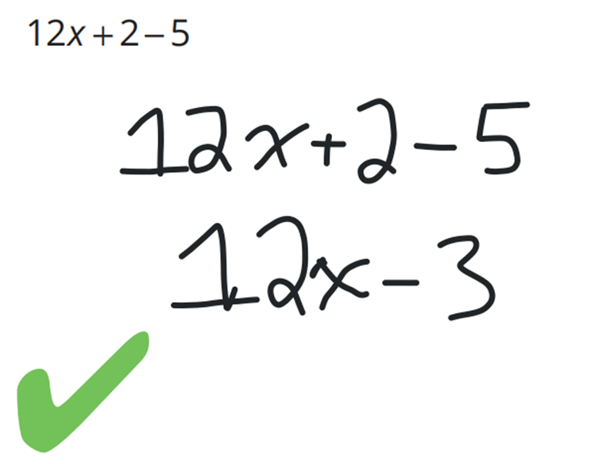  Ramon’s work: | Why didn’t Ramon combine the $12x$ with the $2$ or $-5$?  They are not ………… terms. 2 and $-5$ do not have an ……  Simplify: $3x+4-2$  $3x+2$
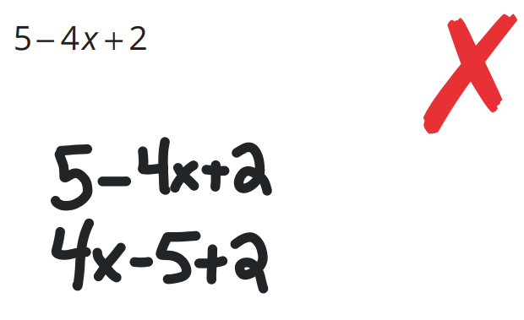  Helaina’s work: | What did Helaina do wrong in her first step?  She didn’t move the ………… with the term.  Would it have been okay to write $5+2-4x$? Explain why or why not.  ………, because the ……… follows the terms.  Simplify: $12x + 4 - 5x$  $7x+4$
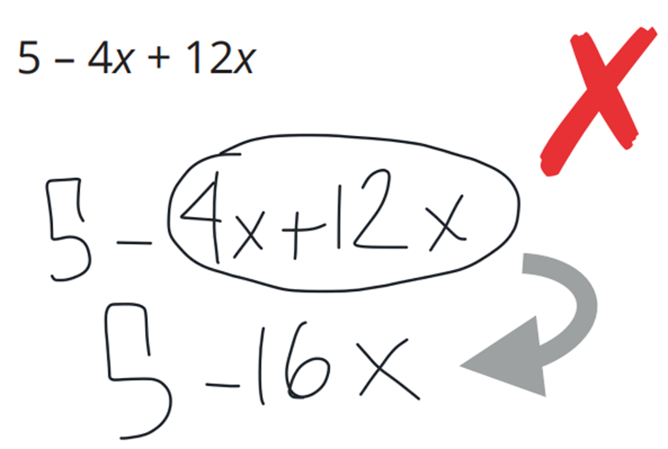  Joseph’s work: | In the step marked with an arrow, what did Joseph do wrong when choosing the terms to combine?  He forgot to include the ………… with the $4x$.  If Joseph had combined like terms correctly, what should he have gotten as the answer in simplest form?  $5+8x$  Simplify: $x-12+5$  $x-7$

- Write simplified expressions for the perimeters of the following shapes.
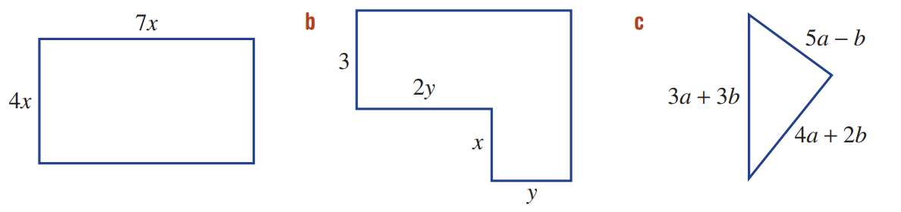  $22x$ | 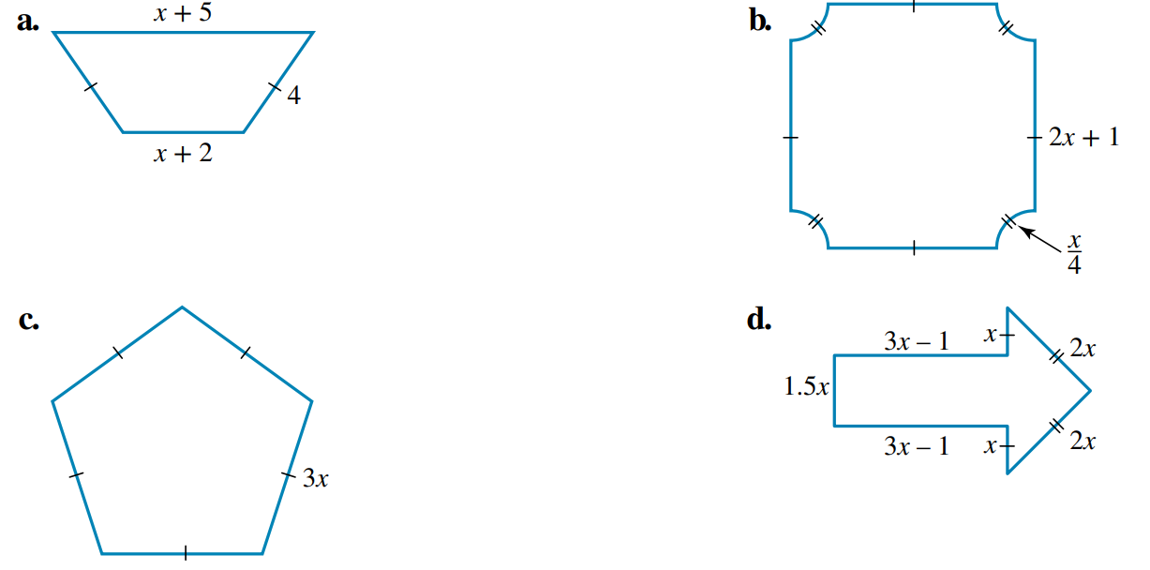  $2x+15$ | $15x$
$6+6y+2x$ | $12a+4b$ | $9x+4$

- Read the example carefully and answer the questions.
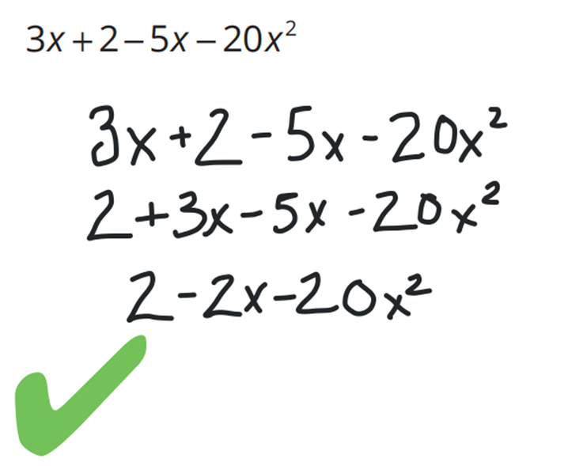  Monica’s work: | Why didn’t Monica combine $-2x$ and $-20x^{2}$ ?  Because they are not ……… terms, they must have the same …………… and the same ……………… for us to combine them.  Simplify: $3x+4-6x^{2}-9$  $-5+3x-6x^{2}$

- Complete each pyramid. Each expression is the sum of the two expressions below it.
$2a+4$  $a+3$, $a+1$ | 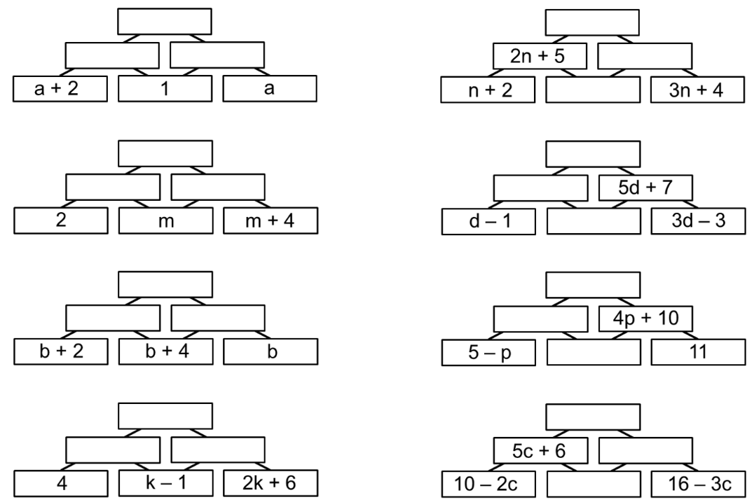  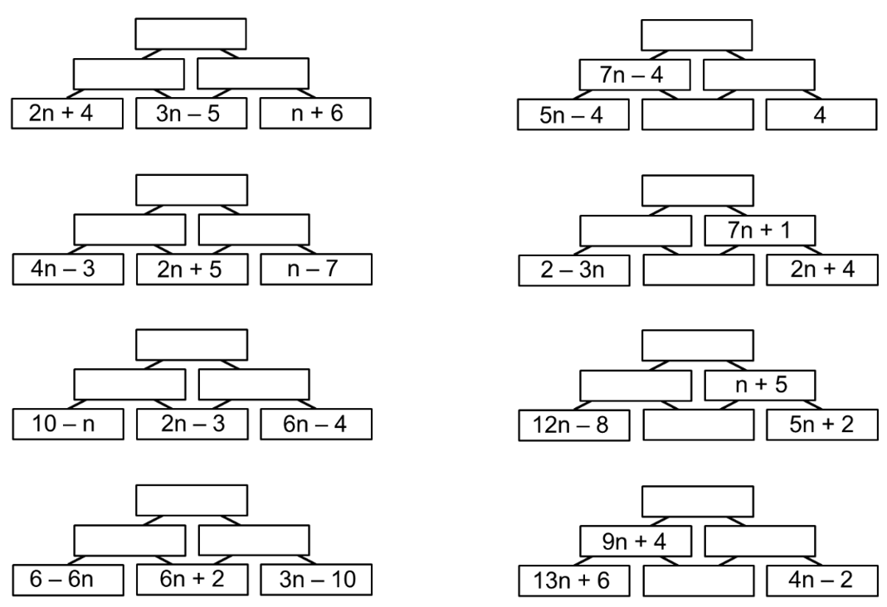  $9n$  $5n-1,4n+1$
$4b+10$  $2b+6,2b+4$ | $9n$  $n+7,8n-7$

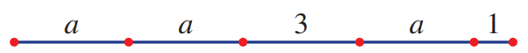
- The length of the line segment shown could be expressed as $a + a + 3 + a + 1$.

  - Write the length in simplest form.
$$3a+4$$
  - What is the length of the segment if $a$ is equal to 5?
19

- Let $x$ represent the number of table tennis balls in a bag.
Asher bought 4 bags and Malachi bought 7 bags.
Write simplified expressions for the number of:
  - Table tennis balls Asher has.
$4x$
  - Table tennis balls Malachi has.
$7x$
  - Table tennis balls that Asher and Malachi have.
$11x$
  - Extra table tennis balls that Malachi has compared to Asher
$3x$
- Simplify the following:
  - $15l + 2 - 3l + 7c - 12c + 6$

$8+12l-5c$
  - $7e+e^{2}+3-e^{2}-5e+6+6a$

$2e+9+6a$
  - $ac + 2pa - 6a + 7 - 5ap + 9ac + 12$

$10ac-3ap+19-6a$

Mastery
- Towels cost $$c$ each at a shop.
  - John buys three towels, Mary buys six towels and Naomi buys four towels.
Write a fully simplified expression for the total amount spent on towels.

$13c$
  - On another occasion, Chris buys $n$ towels.
David buys twice as many as Chris and Edward buys three times as many as David.
Write a simplified expression for the total amount they spent on towels.

$9nc$

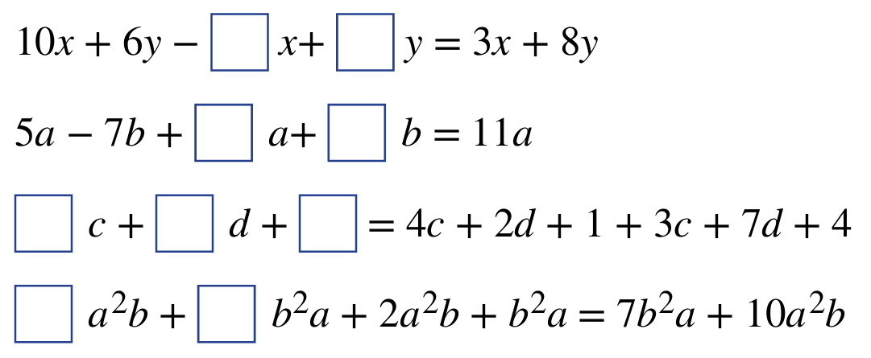
- Find the missing numbers to make these equations true.

7, 2

6, 7
7, 9, 5
8, 6

- Add the missing expressions to the puzzle to make all six equations true.
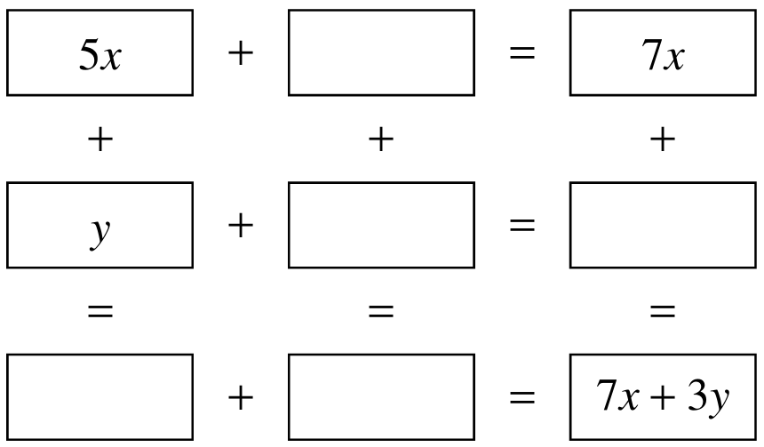

$2x$
$2y, 3y$
$5x+y, 2x+2y$

- Complete each pyramid. Each expression is the sum of the two expressions below it.
$6n+12$  $4n+7$  $n+3$ | $8d+16$  $3d+9$  $2d+10$
$7p+14$  $3p+4$  $4p-1$ | $9c+26$  $4c+20$  $7c+4$
$9n$  $2n+4$  $2n$ | $9n+6$  $2n+5$  $5n+3$
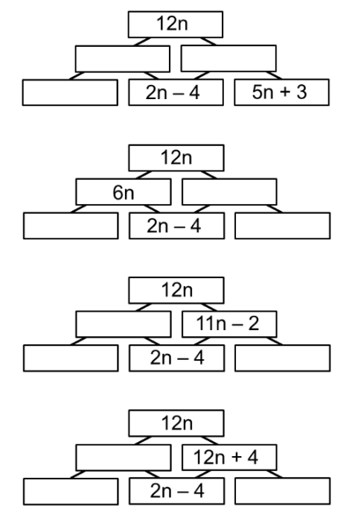  $5n+1, 7n-1$  $3n+5$ | $6n$  $4n+4, 4n+4$
$n+2$  $-n+6, 9n+2$ | $-4$  $-2n, 10n+8$

- Fill in the missing expressions to make all eight equations true.
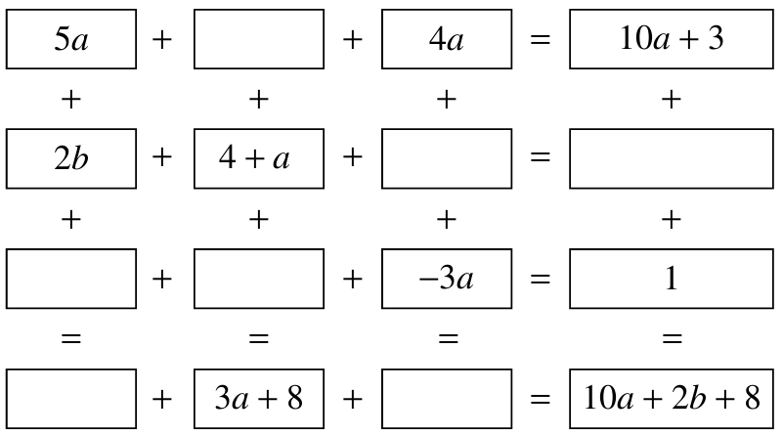

$a+3$
$-a, 2b+4$
$2a, a+1$
$7a+2b, 0$

Further Adding and Subtracting Terms

- Like Terms with Powers
Like terms have the same variables with the same powers.

Foundation
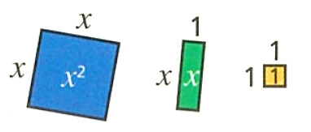
- The area of each tile is shown.

Write an expression for the value of these tiles:
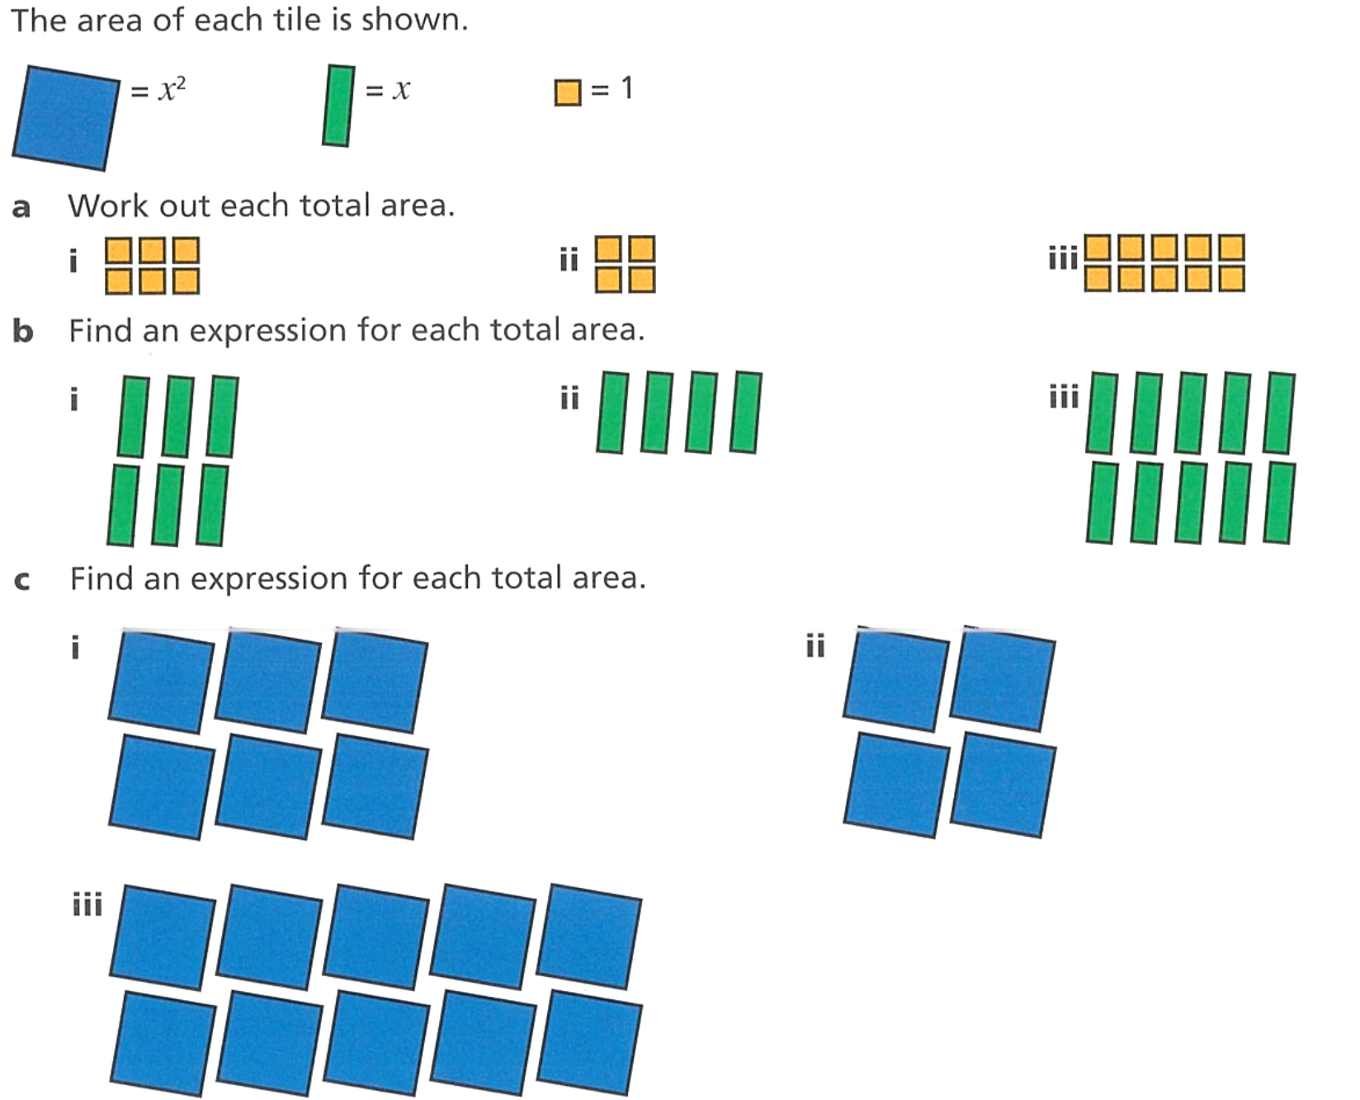  $6$ | $4$ | $10$
$6x$ | $4x$ | $10x$
$6x^{2}$ | $4x^{2}$ | $10x^{2}$

- Simplify each expression.
- $x^{2}+x^{2}+x^{2}$  $3x^{2}$ | - $2x^{2}+x^{2}+x^{2}$  $4x^{2}$ | - $2x^{2}+x^{2}-x^{2}$  $2x^{2}$
- $8x^{2}+5x^{2}-3x^{2}$  $10x^{2}$ | - $y^{2}+4y^{2}-3y^{2}$  $$2y^{2}$$ | - $5p^{2}-2p^{2}+4p^{2}$  $7p^{2}$

- Zach writes $5x^{2}+5x+3x^{2}=13x^{2}$. Explain why Zach is incorrect. Draw a diagram if necessary.

$5x$ is not a like term as it has different power.
- Write an expression for the total area.
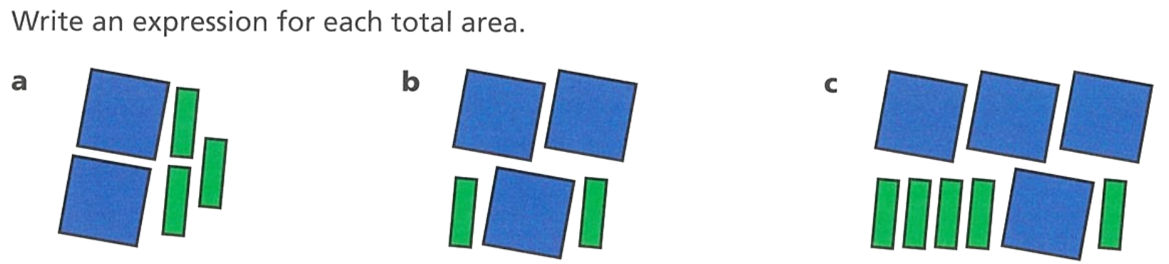  $2x^{2}+3x$ | $3x^{2}+2x$ | $4x^{2}+5x$

- The volume of each cube is $x^{3}$. Write an expression for each total volume.
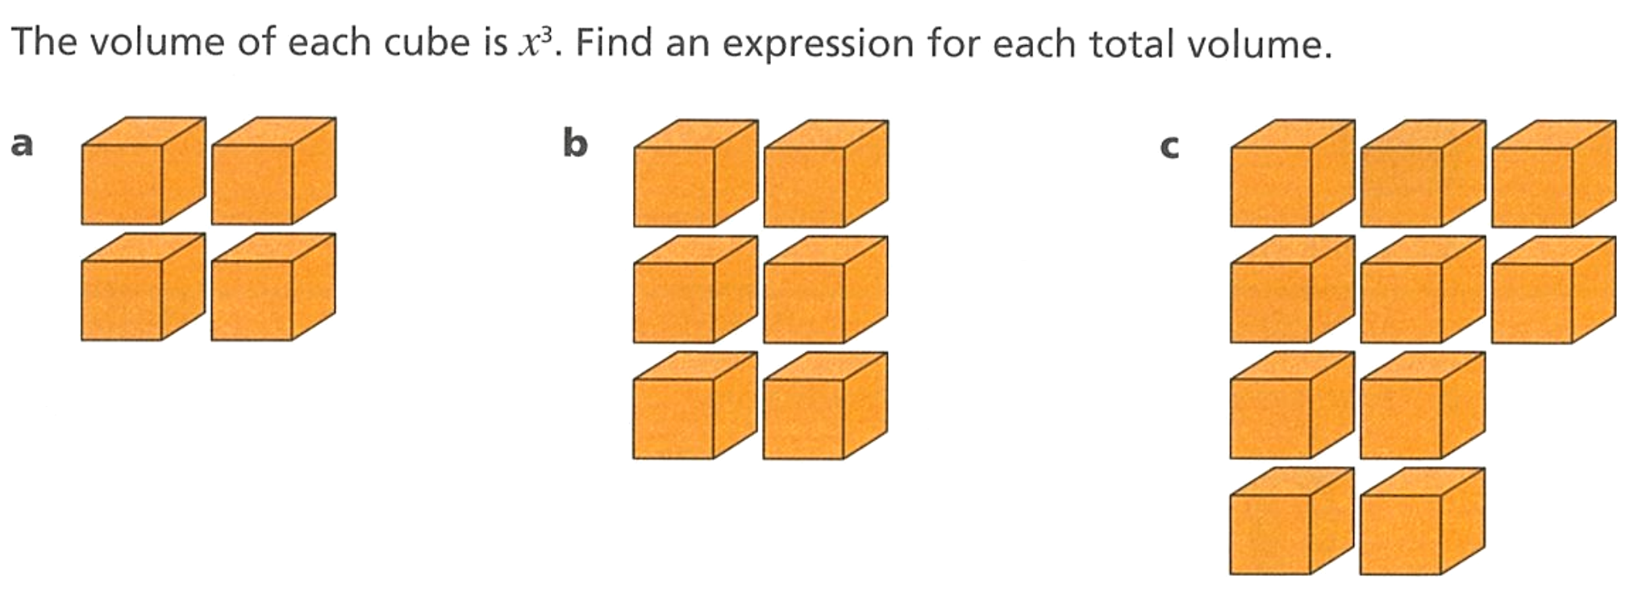  $4x^{3}$ | $6x^{3}$ | $8x^{3}$

- Simplify each expression.
- $5x^{3}+9x^{3}$  $14x^{3}$ | - $7y^{3}-4y^{3}$  $3y^{3}$ | - $10p^{3}-2p^{3}-3p^{3}$  $5p^{3}$
- $27x^{3}-26x^{3}$  $x^{3}$ | - $11y^{3}+2y^{3}-y^{3}$  $12y^{3}$ | - $16t^{3}+15t^{3}-7t^{3}$  $24t^{3}$

- Explain how the diagram shows that $5x^{3}+2x^{2}$ cannot be simplified.
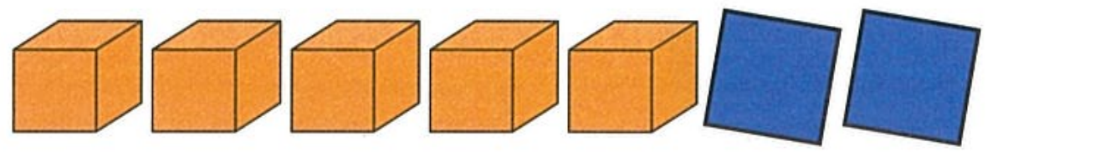

Cubes and squares are not like terms, so we cannot combine them.

Development
- Simplify each expression.
- $12y^{3}+2x^{2}-5y^{3}$  $$7y^{3}+2x^{2}$$ | - $5x^{2}-9x^{2}+4x^{3}$  $-4x^{2}+4x^{3}$ | - $8x^{3}+2x^{2}-7x$  $8x^{3}+2x^{2}-7x$
- $x^{3}+6x^{2}-2x^{3}$  $-x^{3}+6x^{2}$ | - $4m^{3}+12m^{2}-11m^{2}$  $4m^{3}+m^{2}$ | - $21h^{3}+21h^{2}-h^{3}$  $20h^{3}+21h^{2}$

- Simplify the following.
- $a^{2}+b^{2}+a^{2}+b^{2}$  $2a^{2}+2b^{2}$ | - $6a^{2}-5ab-4a^{2}-3ba$  $2a^{2}-8ab$
- $6a^{2}+b^{2}+a^{2}+b^{2}$  $7a^{2}+2b^{2}$ | - $6a^{2}-5a^{2}b-4a^{2}-3a^{2}b$  $2a^{2}-8a^{2}b$
- $6a^{2}+5b^{2}+a^{2}+b^{2}$  $7a^{2}+6b^{2}$ | - $6a^{2}-5a^{2}b-4a^{2}+3a^{2}b$  $2a^{2}-2a^{2}b$
- $6a^{2}+5b^{2}+4a^{2}+b^{2}$  $10a^{2}+6b^{2}$ | - $6a^{2}-5a^{2}b-4a^{2}+3ab^{2}$  $2a^{2}-5a^{2}b+3ab^{2}$
- $6a^{2}+5b^{2}+4a^{2}+3b^{2}$  $10a^{2}+8b^{2}$ | - $6a^{2}-5ab^{2}-4a^{2}+3ab^{2}$  $2a^{2}-2ab^{2}$
- $6a^{2}+5b^{2}-4a^{2}+3b^{2}$  $2a^{2}+8b^{2}$ | - $-6a^{2}-5ab^{2}-4a^{2}+3ab^{2}$  $-10a^{2}-2ab^{2}$
- $6a^{2}+5b^{2}-4a^{2}-3b^{2}$  $2a^{2}+2b^{2}$ | - $-6-5ab^{2}-4+3ab^{2}$  $-10-2ab^{2}$
- $6a^{2}-5b^{2}-4a^{2}-3b^{2}$  $2a^{2}-8b^{2}$ | - $-6a-5ab^{2}-4a+3ab^{2}$  $-10a-2ab^{2}$
- $6a^{2}-5b-4a^{2}-3b$  $2a^{2}-8b$ | - $-6ab-5ab^{2}-4ab+3ab^{2}$  $-10ab-2ab^{2}$
- $6a^{2}-5ab-4a^{2}-3ab$  $2a^{2}-8ab$ | - $-6a^{2}b-5ab^{2}-4a^{2}b+3ab^{2}$  $-10a^{2}b-2ab^{2}$

Multiplying Terms

- Multiplying Terms
- Algebraic expressions don't use multiplication signs $×$
- To simplify expressions involving multiplication:
- Multiply the numbers.
- Multiply the pronumerals.

- Example Simplify expressions involving multiplication
$2×3×x$  ¯ ¯ ¯  $=6x$  ¯ ¯ | $4x×-3y$  ¯ ¯ ¯¯ ¯  $=-12xy$  ¯¯¯ ¯¯ | $2x×5x$  ¯ ¯ ¯ ¯  $=10x^{2}$  ¯¯ ¯

- Guided Practice
Simplify these expressions.
- $2×4×x$  $8x$ | - $3×x×4×y$  $12xy$ | - $3x×5y$  $15xy$ | - $4z×7w$  $28zw$
- $-x×9n$  $-9xn$ | - $2y×5y$  $10y^{2}$ | - $3ab×a$  $3a^{2}b$ | - $3ab×8bc$  $24ab^{2}c$

- Key Ideas
- To multiply two terms, we multiply the ………………… and multiply the …………………
- A fully simplified expression should not have any ………………… symbols.

Foundation
- Simplify these expressions.
- $2×x$  $2x$ | - $3×2×a$  $6a$ | - $8×a×b$  $8ab$
- $5×2×a×b$  $10ab$ | - 2$×b×5$  $10b$ | - $5×a×4×b$  $20ab$
- $x×7×z×4$  $28xz$ | - $2×a×3×b×6$  $36ab$ | - $2×a×a×y×3$  $$6a^{2}y$$

- Simplify these expressions.
- $3a×12$  $36a$ | - $7d×9$  $63d$ | - $4a×3b$  $12ab$
- $7e×9g$  $63eg$ | - $8a×bc$  $8abc$ | - $4d×7af$  $28adf$
- $a×3b×4c$  $12abc$ | - $2a×4b×c$  $8abc$ | - $-3a×2g$  $-6ag$

- Identify the factors of these terms.
3, $h$, $k$ | 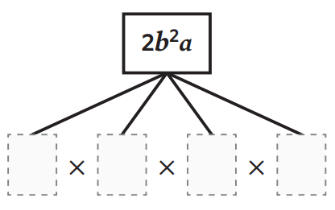  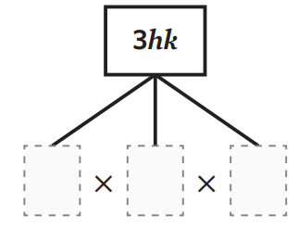  $2$, $b$, $b$, $a$ | 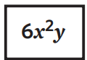  $6$, $x$, $x$, $y$

- Simplify these expressions.
- $w×w$  $w^{2}$ | - $a^{2}×a$  $a^{3}$ | - $3d×d$  $3d^{2}$
- $2k×k^{2}$  $2k^{3}$ | - $p×7p$  $7p^{2}$ | - $q×3q^{2}$  $3q^{3}$
- $6x×2x$  $12x^{2}$ | - $3z×5z^{3}$  $15z^{4}$ | - $-3x×9x×2xy$  $-54x^{3}y$

Development
- Write a simplified expression for the area of the following rectangles.
Recall that $Area=length×breadth$
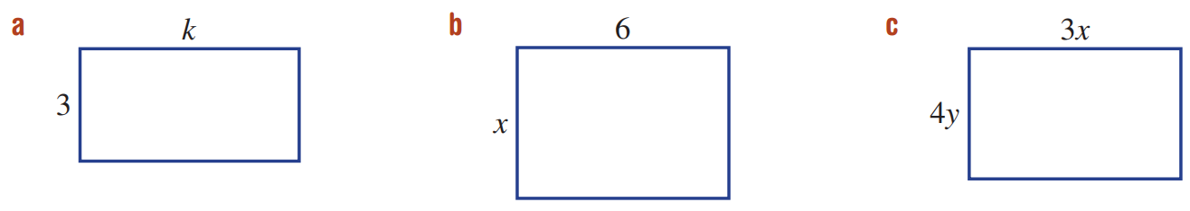  $3k$ | $6x$ | $12xy$
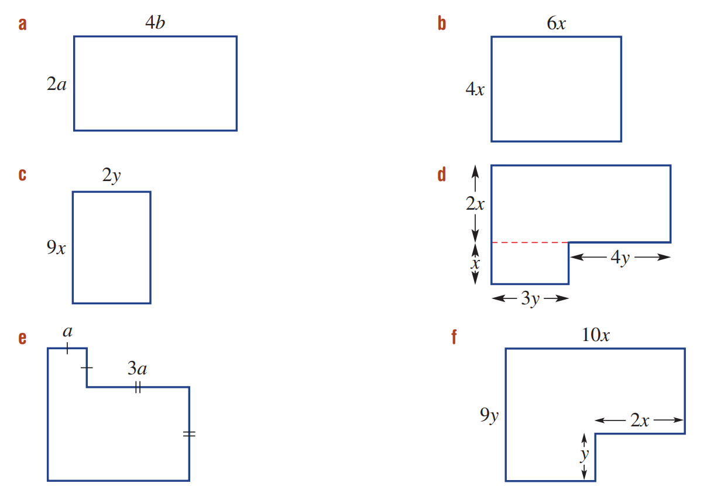  $8ab$ | $24x^{2}$ | $18xy$

- Simplify these expressions.
- $8ab×c$  $8abc$ | - $7x×2y×x$  $14x^{2}y$ | - $5d×2d×e$  $10d^{2}e$
- $4xy×2xz$  $8x^{2}yz$ | - $5xy×2x$  $10x^{2}y$ | - $9ab×2a^{2}$  $18a^{3}b$
- $4abc×2abd$  $8a^{2}b^{2}cd$ | - $-5xy×2yz$  $-10xy^{2}z$ | - $-3xz×(-2z)$  $6xz^{2}$

- A farmer has $x$ pigs and $y$ chickens.
  - Write an expression for the total number of heads.

$x+y$
  - Write an expression for the total number of legs.

$4x+2y$

Mastery
- The weight of a single muesli bar is $x$ grams
  - What is the weight of 4 bars? Write an expression.

$4x$
  - If Jamila buys $n$ bars, what is the total weight of her purchase?

$nx$
  - Jamila’s cousin Roland buys twice as many bars as Jamila.
What is the total weight of Roland’s purchase?

$2nx$
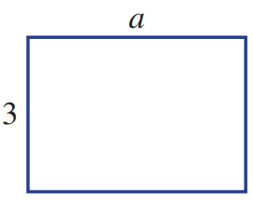
- The area of the rectangle shown is $3a$.
The length and breadth of this rectangle are now doubled.
  - Label the new rectangle, showing its dimensions.

  - How much larger is the area of the new rectangle, compared to the old rectangle?
Show your reasoning.

4 times as large
  - How much larger would the new rectangle be if the lengths were tripled?

9 times as large
- Write a simplified expression for the area of the following composite shapes.
$17xy$ | $13a^{2}$ | $88xy$

Dividing Terms: Numerical HCF

- HCF of Two Terms
- A factor is a number that divides evenly into another term.
- The highest common factor is largest factor shared by two terms.

- Identify HCF of two terms
Identify the HCF of:
$2x$ and $4x$  2 |  | $6n$ and 9  3 |  | $6y$ and $18$  6
Identify the highest common factor of:
- $20$ and $35$  5 | - $15$ and $10x$  5 |  | - $20a$ and $12b$  4 |  | - $27a$ and $9$  9
- $12x$ and $-9$  3 | - $12$ and $8y$  4 |  | - $-36y$ and $9x$  9 |  | - $15$ and $30z$  15
- $20x$ and $15$  5 |  | - $10x$ and $15$  5 |  | - $5x$ and $15$  5
- $15$ and $10x$  5 |  | - $20a$ and $12b$  4 |  | - $27a$ and $9b$  9
- $7y$ and $14x$  7 |  | - $-2y$ and $4x$  2 |  | - $11y$ and $-33x$  11
- $8q$ and $-4r$  4 |  | - $-3a$ and $6$  3 |  | - $15p$ and $25q$  5

- Dividing Terms
- Algebraic expressions don’t use division signs $÷$
- To simplify expressions involving division:
- Rewrite any divisions as fractions.
- Divide the numerator and denominator by common factors.
Also known as “cancelling.”

- Example Simplify expressions involving division (numerical HCF)
$20p÷15$  $=$ $\frac{20p}{15}$ $\frac{÷5}{÷5}$  $=$ $\frac{4p}{3}$ | $18y÷3x$  $=$ $\frac{18y}{3x}$ $\frac{÷3}{÷3}$  $$=\frac{6y}{x}$$

- Guided Practice
Simplify these expressions.
- $15x÷6$  $$=\frac{15x}{6} \frac{÷}{÷}$$  $$=$$  $$\frac{5x}{2}$$ | - $15x÷5$  $3x$ | - $24÷6p$  $$\frac{4}{p}$$ | - $35÷70x$  $$\frac{1}{2x}$$
- $\frac{-2x}{6}$  $$-\frac{x}{3}$$ | - $\frac{15a}{5b}$  $$\frac{3a}{b}$$ | - $\frac{3a}{6x}$  $$\frac{a}{2x}$$ | - $\frac{-2y}{4a}$  $$-\frac{y}{2a}$$

- Key Ideas
- We simplify algebraic division by writing it as a …………………… then dividing the numerator and denominator by common …………………

Foundation
- Simplify these expressions.
- $10y÷15$  $$=\frac{10y}{15}$$  $=$  $$\frac{2y}{3}$$ | - $8÷12m$  $$\frac{2}{3m}$$ | - $6x÷8$  $$\frac{3x}{4}$$
- $9x÷18$  $$\frac{x}{2}$$ | - $3m÷12$  $$\frac{m}{4}$$ | - $5p÷25$  $$\frac{p}{5}$$
- $10c÷2$  $$5c$$ | - $8a÷4$  $$2a$$ | - $6a÷12$  $$\frac{a}{2}$$

- Simplify these expressions.
- $\frac{5f}{10e}$  $$\frac{f}{2e}$$ | - $\frac{6k}{8m}$  $$\frac{3k}{4m}$$ | - $\frac{9c}{6}$  $$\frac{3c}{2}$$
- $\frac{7x}{7}$  $$x$$ | - $\frac{6ab}{2}$  $$3ab$$ | - $-\frac{3ab}{9}$  $$-\frac{ab}{3}$$
- $\frac{8b}{12}$  $$\frac{2b}{3}$$ | - $-\frac{2a}{6}$  $$-\frac{a}{3}$$ | - $\frac{4ab}{6}$  $$\frac{2ab}{3}$$
- $\frac{10}{12x}$  $$\frac{5}{6x}$$ | - $\frac{4t}{8}$  $$\frac{t}{2}$$ | - $\frac{9w}{15ay}$  $$\frac{3w}{5ay}$$
- $\frac{16tu^{2}}{3}$  $$\frac{16tu^{2}}{3}$$ | - $\frac{5r^{2}}{25d}$  $$\frac{r^{2}}{5d}$$ | - $\frac{12e^{2}}{18h}$  $$\frac{2e^{2}}{3h}$$

Dividing Terms: Algebraic HCF

- HCF of Two Terms
- The algebraic HCF is the largest term that divides two terms evenly.
- To find the algebraic HCF:
- Find the HCF of the numbers.
- Find the HCF of the pronumerals.
- Multiply these HCFs together.

- Identify HCF of two terms
Identify the HCF of:
$xy$ and $x$  $$x$$ | $2xy$ and $6x$  $$2x$$ | $14x^{2}$ and $21x$  $$7x$$
Identify the highest common factor of:
- $5x$ and $2xy$  $x$ | - $7xy$ and $14x$  $7x$ | - $-2yz$ and $4xy$  $2y$
- $11y$ and $-33xy$  $11y$ | - $2xy$ and $y^{2}$  $y$ | - $5ab$ and $10a^{2}b$  $5ab$

Foundation
- Find the highest common factor of the following pairs of terms.
- $5x$ and $7x$  $x$ | - $20a$ and $12b$  $4$ | - $27a$ and $9b$  $9$
- $7xy$ and $14x$  $7x$ | - $-2xy$ and $4xy$  $2xy$ | - $11xy$ and $-33xy$  $11xy$
- $8qr$ and $-4r$  $4r$ | - $5a$ and $6a^{2}$  $a$ | - $14p$ and $25pq$  $p$
- $6x$ and $12xy$  $6x$ | - $-3a$ and $6a^{2}$  $3a$ | - $abc$ and $b^{2}c$  $bc$

- Find the HCF.
- $x$ and $2x$  $$x$$ | - $3x^{2}$ and $2y$  $$1$$ | - $8x^{2}$ and $12x^{5}y$  $$4x^{2}$$
- $x$and $3x$  $$x$$ | - $7x^{2}$ and $2y$  $$1$$ | - $8x^{2}y$ and $12x^{5}y$  $$4x^{2}y$$
- $x$ and $3x^{2}$  $$x$$ | - $7x^{2}$ and $2xy$  $$x$$ | - $16x^{2}y$ and $24x^{5}y$  $$8x^{2}y$$
- $3x^{2}$ and $x$  $$x$$ | - $8x^{2}$ and $2xy$  $$2x$$ | - $16x^{2}y^{3}$ and $24x^{5}y$  $$8x^{2}y$$
- $3x^{2}$ and $2x$  $$x$$ | - $8x^{2}$ and $2x^{5}y$  $$2x^{2}$$ | - $16x^{2}y^{3}$ and $24x^{5}y^{3}$  $$8x^{2}y^{3}$$

- Dividing Terms
- To simplify expressions involving division:
- Rewrite any divisions as fractions.
- Divide the numerator and denominator by common factors.
Also known as “cancelling.”

- Example Simplify expressions involving division (numerical HCF)
$4ab÷3a=$ $\frac{4ab}{3a}$ $\frac{÷a}{÷a}$  $=$ $\frac{4b}{3}$ | $8ab÷12b=$ $\frac{8ab}{12b}$ $\frac{÷b}{÷b}$  $=$ $\frac{8a}{12}$ $\frac{÷4}{÷4}$  $$=\frac{2a}{3}$$

- Guided Practice
Simplify these expressions.
- $8m÷3m$  $$=\frac{8m}{3m} \frac{÷}{÷}$$  $=$  $$\frac{8}{3}$$ | - $6a÷12a$  $$\frac{1}{2}$$ | - $3ab÷2b$  $$\frac{3a}{2}$$ | - $6x÷8xy$  $$\frac{3}{4y}$$
- $\frac{2x}{5x}$  $$\frac{2}{5}$$ | - $-\frac{5a}{9a}$  $$-\frac{5}{9}$$ | - $\frac{9ab}{4b}$  $$\frac{9a}{4}$$ | - $\frac{2ab}{-5a}$  $$\frac{2b}{-5}$$
- $\frac{a^{2}}{a}$  $$a$$ | - $\frac{x}{x^{2}}$  $$\frac{1}{x}$$ | - $\frac{2x^{2}}{6x}$  $$\frac{x}{3}$$ | - $\frac{6x^{2}}{4y}$  $$\frac{3x^{2}}{2y}$$

- Key Ideas
- We simplify algebraic division by writing it as a …………………… then dividing the numerator and denominator by common …………………

Foundation
- Simplify these expressions.
- $\frac{3f}{7ef}$  $$\frac{3}{7e}$$ | - $\frac{4m}{5m}$  $$\frac{4}{5}$$ | - $\frac{3c}{7ec}$  $$\frac{3}{7e}$$
- $\frac{2d^{2}}{d}$  $$2d$$ | - $\frac{8abc}{2ab}$  $$4c$$ | - $\frac{4ab}{2a}$  $$2b$$
- $\frac{6q^{2}y}{11q}$  $$\frac{6qy}{11}$$ | - $\frac{abc}{ab^{2}c}$  $$\frac{1}{b}$$ | - $\frac{x^{2}}{5x}$  $$\frac{x}{5}$$
- $\frac{4t}{6t}$  $$\frac{2}{3}$$ | - $\frac{10k}{2kn}$  $$\frac{5}{n}$$ | - $\frac{3ab}{12b}$  $$\frac{a}{4}$$
- $\frac{t}{3t}$  $$\frac{1}{3}$$ | - $-\frac{15xy}{5y}$  $$-3x$$ | - $\frac{-28ab}{56b}$  $$-\frac{a}{2}$$
- $\frac{15h}{5h^{2}}$  $$\frac{3}{h}$$ | - $\frac{4a^{2}v}{6v^{2}}$  $$\frac{2a^{2}}{3v}$$ | - $\frac{9fg}{7g^{2}}$  $$\frac{9f}{7g}$$
- Simplify these expressions.
- $\frac{3}{12}$  $$\frac{1}{4}$$ | - $\frac{10x}{12xy}$  $$\frac{5}{6y}$$
- $\frac{3x}{12}$  $$\frac{x}{4}$$ | - $\frac{10x}{12xy^{2}}$  $$\frac{5}{6y^{2}}$$
- $\frac{3}{12x}$  $$\frac{1}{4x}$$ | - $\frac{10xy}{12xy^{2}}$  $$\frac{5}{6y}$$
- $\frac{12x}{3}$  $$4x$$ | - $\frac{10x^{2}y}{12xy^{2}}$  $$\frac{5x}{6y}$$
- $\frac{12x}{6}$  $$2x$$ | - $\frac{10x^{2}y^{2}}{12xy^{2}}$  $$\frac{5x}{6}$$
- $\frac{12x}{6x}$  $$2$$ | - $\frac{10x^{2}y^{3}}{12xy^{2}}$  $$\frac{5xy}{6}$$
- $\frac{12xy}{6x}$  $$2y$$ | - $\frac{100x^{2}y^{4}}{120xy^{2}}$  $$\frac{5xy^{2}}{6}$$
- $\frac{6x}{12xy}$  $$\frac{1}{2y}$$ | - $\frac{100x^{2}y^{4}}{xy^{2}}$  $$100xy^{2}$$

Development
- Simplify these expressions.
- $2x×3$  $6x$ | - $\frac{24x^{2}y^{3}}{2x}$  $12xy^{3}$
- $2×3x$  $6x$ | - $\frac{24x^{2}y^{3}}{2y}$  $12x^{2}y^{2}$
- $2x×3x$  $6x^{2}$ | - $\frac{24x^{2}y^{3}}{{2y}^{2}}$  $12x^{2}y$
- $2x×3x^{2}$  $6x^{3}$ | - $\frac{24x^{2}y^{3}}{2xy}$  $12xy^{2}$
- $2x×3x^{2}×4$  $24x^{3}$ | - $\frac{24x^{2}y^{3}}{6xy}$  $4xy^{2}$
- $2x×3x^{2}×4y$  $24x^{3}y$ | - $\frac{24x^{2}y^{3}}{6x^{2}}$  $4y^{3}$
- $2y×3x^{2}×4y$  $24x^{2}y^{2}$ | - $\frac{24x^{2}y^{3}}{6y^{2}}$  $4x^{2}y$
- $2y^{2}×3x^{2}×4y$  $24x^{2}y^{3}$ | - $\frac{24x^{2}y^{3}}{6x^{2}y}$  $4y^{2}$
- $\frac{2y^{2}×3x^{2}×4y}{2}$  $12x^{2}y^{3}$ | - $\frac{24x^{2}y^{3}}{24x^{2}y^{3}}$  $1$

- Simplify these expressions.
- $48x^{2}y^{3}÷4$  $12x^{2}y^{3}$ | - $48x^{2}y^{3}÷8$  $6x^{2}y^{3}$ | - $48x^{2}y^{3}÷4x$  $12xy^{3}$
- $48x^{2}y^{3}÷8y$  $6x^{2}y^{2}$ | - $48x^{2}y^{3}÷12xy$  $4xy^{2}$ | - $48x^{2}y^{3}÷6x^{2}$  $8y^{3}$
- $48x^{2}y^{3}÷6y^{2}$  $8x^{2}y$ | - $48x^{2}y^{3}÷16x^{2}y^{2}$  $3y$ | - $48x^{2}y^{3}÷48x^{2}y^{3}$  $1$

Mixed Practice

- Simplifying Expressions
Adding & Subtracting | Multiplying | Dividing
- Identify like terms  - Add the like terms  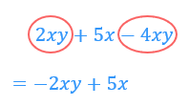 | - Multiply numbers  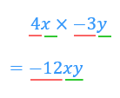  - Multiply pronumerals | - Rewrite as fraction  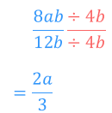  - Divide numerator and denominator by common factors

Foundation
- Simplify the following expressions by collecting like terms.
- $3x+2x$  $$5x$$ | - $7a+12a$  $$19a$$ | - $15x-6x$  $$9x$$
- $4xy+3xy$  $$7xy$$ | - $16uv-3uv$  $$13uv$$ | - $10ab+4ba$  $$14ab$$
- $11ab-5ba+ab$  $$7ab$$ | - $3k+15k-2k$  $$16k$$ | - $15k-2k-3k$  $$10k$$
- $7f+2f+8+4$  $$9f+12$$ | - $10x+3x+5y+3y$  $$13x+8y$$ | - $2a+5a+13b-2b$  $$7a+11b$$
- $10+5x-2+7x$  $$12x+8$$ | - $10x+31y-y+4x$  $$14x+30y$$ | - $7x^{2}y+5x+10yx^{2}$  $$17x^{2}y+5x$$
- $12xy-3yx+5xy-yx$  $$13xy$$ | - $-4x^{2}+3x^{2}$  $$-x^{2}$$ | - $-2a+4b-7ab+4a$  $$2a+4b-7ab$$

- Simplify the following.
- $5×2m$  $10m$ | - $3×5p$  $15p$ | - $3x×2y$  $6xy$
- $3p×6r$  $18pr$ | - $-2x×7y$  $-14xy$ | - $-4c×3d$  $-12cd$
- $2a×3b×5$  $30ab$ | - $-4r×3×2s$  $-24rs$ | - $5j×\left(-4\right)×2k$  $-40jk$
- Simplify these expressions.
- $\frac{2x}{5x}$  $$\frac{2}{5}$$ | - $\frac{5a}{9a}$  $$\frac{5}{9}$$ | - $\frac{9ab}{4b}$  $$\frac{9a}{4}$$
- $\frac{2ab}{5a}$  $$\frac{2b}{5}$$ | - $\frac{2x}{4}$  $$\frac{x}{2}$$ | - $\frac{9x}{12}$  $$\frac{3x}{4}$$
- $\frac{10a}{15a}$  $$\frac{2}{3}$$ | - $\frac{30y}{40y}$  $$\frac{3}{4}$$ | - $\frac{4a}{2}$  $$2a$$
- $\frac{21x}{7x}$  $$3$$ | - $\frac{4xy}{2x}$  $$2y$$ | - $\frac{9x}{3xy}$  $$\frac{3}{y}$$
- $\frac{-5x}{10yz^{2}}$  $$-\frac{x}{2yz^{2}}$$ | - $\frac{12y^{2}}{-18y}$  $$-\frac{2y}{3}$$ | - $\frac{-4a^{2}}{8ab}$  $$-\frac{a}{2b}$$
- $\frac{12p}{-3q}$  $$-\frac{4p}{q}$$ | - $\frac{-21p}{-3p}$  $$7$$ | - $\frac{-15z}{-20z^{2}}$  $$\frac{3}{4z}$$

- Simplify the following:
- $4n×6n$  $24n^{2}$ | - $5s× 2s$  $10s^{2}$ | - $7a×3ab$  $21a^{2}b$
- $-4b×2d$  $-8bd$ | - $-3mn×mn×4n$  $-12m^{2}n^{3}$ | - $9k×(-7)$  $-63k$
- $5mn×(-3n)$  $-15mn^{2}$ | - $-3gh×(-6g)$  $18g^{2}h$ | - $3xy×4xy$  $12x^{2}y^{2}$
- $-4ab×(-2ab)$  $8a^{2}b^{2}$ | - $-2mn×3m$  $-6m^{2}n$ | - $5hj×\left(-4h\right)×2k$  $-40h^{2}jk$
- $\frac{-3xy}{6y}$  $$-\frac{x}{2}$$ | - $\frac{21xz}{-7xy}$  $$-\frac{3z}{y}$$ | - $\frac{-12y}{-3y^{2}}$  $$\frac{4}{y}$$

Development
- Simplify these expressions, if possible.
- $3+b$  can’t simplify | - $b×3$  $3b$ | - $3a×b^{2}$  $3ab^{2}$
- $3×b$  $3b$ | - $2b×3$  $6b$ | - $3a×a^{3}$  $3a^{4}$
- $b+b+b$  $3b$ | - $3×2b$  $6b$ | - $3a×{ba}^{2}$  $3a^{3}b$
- $b×b×b$  $b^{3}$ | - $3b×2b$  $6b^{2}$ | - $2×b×a$  $2ab$
- $b×a×b$  $ab^{2}$ | - $3b+2b$  $5b$ | - $2+b+a$  can’t simplify
- $b+a+b$  $a+2b$ | - $3a+2b$  can’t simplify | - $2×b+a$  $2b+a$
- $b+3+b$  $2b+3$ | - $3a×2b$  $6ab$ | - $2+b×a$  $2+ab$

- Simplify these expressions.
- $9m+m$  $$10m$$ | - $9m×m$  $$9m^{2}$$ | - $9m÷m$  $$9$$
- $9m+3m$  $$12m$$ | - $9m×3m$  $$27m^{2}$$ | - $9m÷3m$  $$3$$
- $4ab×2ab$  $$8a^{2}b^{2}$$ | - $4ab÷2ab$  $$2$$ | - $4a^{2}b×2ab^{2}$  $$8a^{3}b^{3}$$
- $4a^{2}b÷2a^{2}b$  $$2$$ | - $24a^{3}b÷6ab$  $$4a^{2}$$ | - $24a^{3}b×6ab$  $$144a^{4}b^{2}$$
- $12pq+6pq$  $$18pq$$ | - $12pq÷6$  $$2pq$$ | - $12pq×6q$  $$72pq^{2}$$
- $12pq×6p$  $$72p^{2}q$$ | - $12pq×6pq$  $$72p^{2}q^{2}$$ | - $12pq÷6p$  $$2q$$
- $12pq÷6pq$  $$2$$ | - $12p^{2}q×6pq$  $$72p^{3}q^{2}$$ | - $12pq^{2}÷6pq$  $$2q$$

- Match any pair of equivalent expressions by circling, underlining etc.
There may be expressions with more than one match or that do not have a match.

$5x, 2x+3x, x+x+x+x+x$
$5+x, x+5$
$$\frac{x}{5},\frac{1}{5}x$$
- Simplify each expression, if possible.
- $5x^{2}-4xy^{2}$  can’t simplify | - $3a^{2}b+4ba^{2}$  $$7a^{2}b$$ | - $8m^{2}n-6nm^{2}+m^{2}n$  $$3m^{2}n$$
- $7p^{2}q^{2}-2p^{2}q^{2}-4p^{2}q^{2}$  $$p^{2}q^{2}$$ | - $2x^{2}y-4xy^{2}+5yx^{2}$  $$7x^{2}y-4xy^{2}$$ | - $10rs^{2}+3rs^{2}-6r^{2}s$  $$13rs^{2}-6r^{2}s$$
- $x^{2}-7x-3x^{2}$  $$-2x^{2}-7x$$ | - $a^{2}b-4ab^{2}+3a^{2}b+b^{2}a$  $$4a^{2}b-3ab^{2}$$ | - $10pq^{2}-2qp-3p^{2}q-6$  can’t simplify

- Fill in the empty bricks in the following pyramids.
Each brick is made by adding the expressions in the two bricks below it.
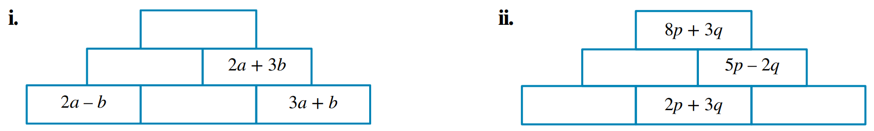  $3a+4b$  $a+b$  $-a+2b$ | $3p+5q$  $p+2q, 3p-5q$

- Fill in the empty bricks in the following pyramids.
Each brick is made by multiplying the expressions in the two bricks below.
$18m^{3}n^{2}$  $3m^{2}n, 6mn$ | 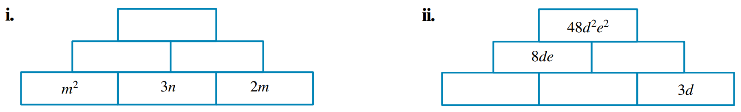  $6de$  $4d, 2e$

- Find the missing numbers to make these equations true.
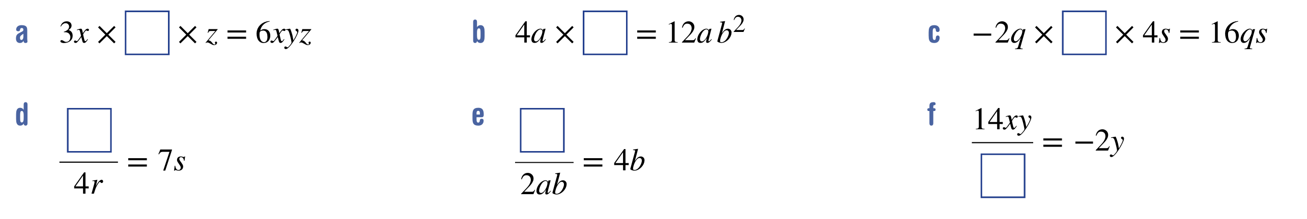  $2y$ | $3b^{2}$
$-2$ | $28rs$
$8ab^{2}$ | $-7x$

- Fill in the empty boxes.
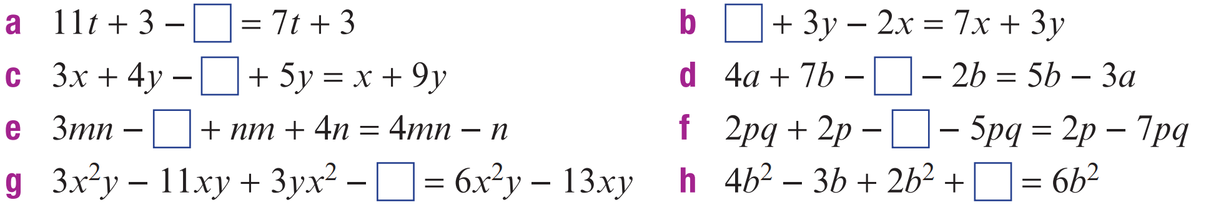  $4t$ | $9x$
$2x$ | $7a$
$5n$ | $4pq$
$2xy$ | $3b$

- Fill in the empty boxes.
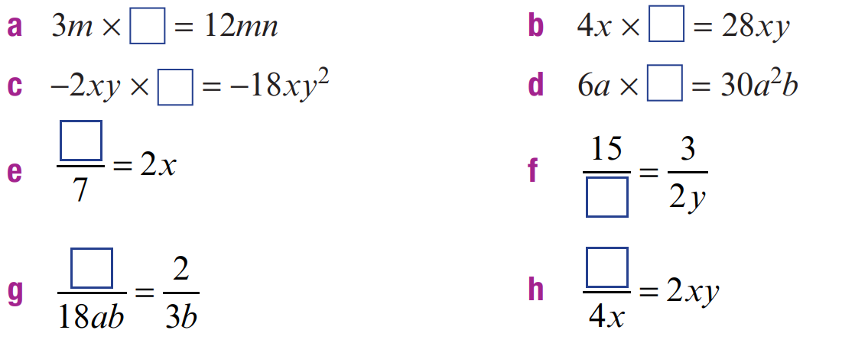  $4n$ | $7y$
$9y$ | $5ab$
$14x$ | $10y$
$12a$ | $8x^{2}y$

- Fill in the empty boxes.
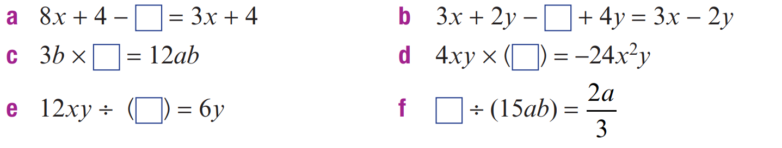  $5x$ | $8y$
$4a$ | $-6x$
$2x$ | $10a^{2}b$

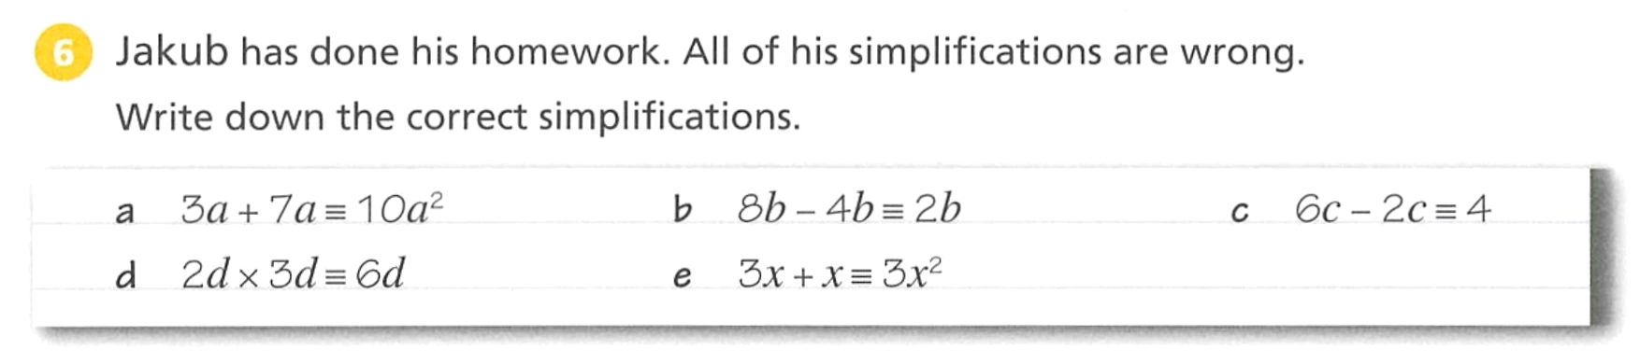
- Jimmy has done his homework. All of his simplifications are incorrect.
Write the correct simplifications.

$10a$ | $4b$ | $4c$
$6d^{2}$ | $4x$

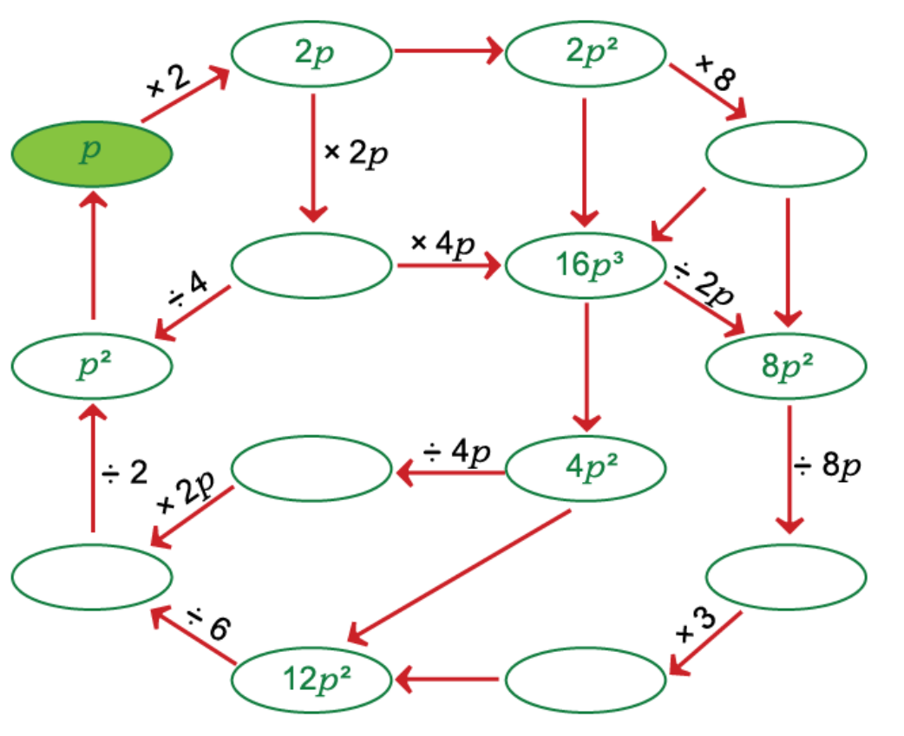
- Complete the diagram.

- The pronumeral $e$ represents the number of eggs in a basket.
Match the expressions to the appropriate scenario. There can be more than one answer.
$2e+2$ $e+2$ $2×e$ $e-e$ $e×2$ $2e+4$
$e+1-1$ $\frac{1}{2}e$ $e-1-1$ $e+e$ $2(e+2)$ $e-2$
$2+e$ $e÷2$ $e+e+2$ $0$ $\frac{e}{2}$ $e+1+1$
$2e$

- Two eggs are added.  $e+1+1$  $e+2$  $2+e$ | - Two eggs are removed.  $e-2$  $e-1-1$
- The number of eggs is doubled.  $2e$  $e+e$  $e×2$  $2×e$ | - The number of eggs is halved.  $$\frac{1}{2}e$$  $$\frac{e}{2}$$  $$e÷2$$
- The number of eggs is doubled and then two are added.  $2e+2$  $e+e+2$ | - Two eggs are added and then  that number is doubled  $$2\left(e+2\right)$$  $$2e+4$$
- All eggs are taken out of the basket.  $e-e$  $0$ | - One egg is added and then  taken back out.  $$e+1-1$$

Simplifying Expressions with Mixed Operations

- Simplifying Expressions with Mixed Operations
For mixed operations, simplify by following the order of operations.

- Example Simplify expressions with mixed operations
$a×4-2×a$  ¯¯¯¯  ¯¯¯¯  $$=4a-2a$$  $$=2a$$ | $4b+\left(2x+4x\right)÷3$  ¯¯¯¯¯¯¯  $$=4b+6x÷3$$  $$=4b+2x$$

- Guided Practice
Simplify these expressions.
- $10x+15x÷5$  $$13x$$ | - $3b-2b×4$  $$-5b$$ | - $3×2x+5x×3$  $$21x$$
- $2×(6b-3b)$  $$6b$$ | - $\left(2x+x\right)÷5$  $$\frac{3x}{5}$$ | - $\left(2+x\right)÷(3y+y)$  $$\frac{2+x}{4y}$$

- Key Ideas
- If there are mixed operations in an algebraic expression, then we simplify by following the ………………… ……… ……………………………

Foundation
- Simplify these expressions. Remember to follow the order of operations.
- $3+a×b$  $3+ab$ | - $(4x+2x)÷5$  $$\frac{6x}{5}$$
- $(2x+y)÷5$  $$\frac{2x+y}{5}$$ | - $(2+x)÷(4y+y)$  $$\frac{2+x}{5y}$$
- $(x-5)÷(3+b)$  $$\frac{x-5}{3+b}$$ | - $2x+y÷5$  $$2x+\frac{y}{5}$$
- $3+x÷2+y$  $$3+\frac{x}{2}+y$$ | - $x-5÷3+b$  $$x-\frac{5}{3}+b$$
- $3×2b-b$  $$5b$$ | - $3×(2b-2b)$  $$0$$
- $6b+15b÷3$  $$11b$$ | - $(6b+15b)÷3$  $$7b$$
- $(c-2c)×4$  $$-4c$$ | - $c-2c×4$  $$-7c$$

- Simplify the following expressions.
- $5p^{2}-2p×3p$  $-p^{2}$ | - $4r^{2}+15r^{3}÷5r$  $7r^{2}$ | - $4b+3×\left(2b^{3}÷b^{2}\right)$  $$10b$$
- $2x+$ $\frac{x^{2}}{x}$  $3x$ | - $\frac{12x^{2}y}{3x}$ $-3xy$  $xy$ | - $\frac{16x^{2}y^{2}}{8xy}$ $-xy+y$  $xy+y$

Modelling with Algebra

Foundation
- Pens cost $3 each.
  - Write an expression for the total cost, in dollars, of $n$ pens.
$\$3n$
  - If $n=12$, find the total cost.
$\$36$

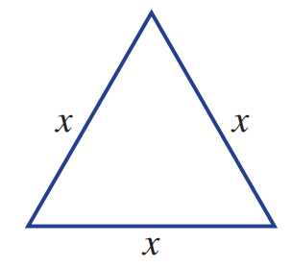
- An equilateral triangle has three sides of the same length.
  - Write an expression that gives the perimeter of this triangle.
$3x$
  - Use your expression to find the perimeter if $x=5$ cm
$15$ cm

- A rectangle has length 5 cm longer than its width.
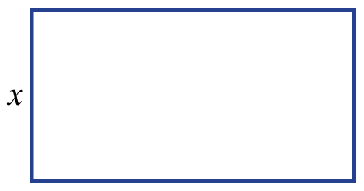
  - If the width is $x$ cm, write an expression for the length.
$$x+5$$
  - Write an expression for the perimeter of the rectangle.
$$4x+10$$
  - Find the perimeter if the width is $3$ cm ($x=3$).
$$22$$

- A rectangle has length 5 times as long as its width.
  - If the width is $x$ cm, write an expression for the length.
$$5x$$
  - Write an expression for the perimeter of the rectangle.
$12x$
  - Find the perimeter if the width is $3$ cm ($x=3$).
$36$ cm

- A car travels at 90 km/h, so in $n$ hours it has travelled $90n$ kilometres.
  - How far does the car travel in 3 hours (i.e. $n = 3$)?
$270$ km
  - How far does the car travel in 30 minutes?
$45$ km
  - Write an expression for the distance travelled in $n$ hours for a bike with speed 70 km/h.
$70n$

Development
- A carpenter charges a $40 call-out fee and then $80 per hour.
This means the total cost for $x$ hours of work is $\$(40 + 80x)$
  - How much would it cost for a 2-hour job (i.e. $x = 2$)?
$\$200$
  - How much would it cost for a job that takes 8 hours?
$\$680$
  - The call-out fee is increased to $50. What is the new expression for the cost of $x$ hours?
$50+80x$
- An electrician charges a call-out fee of $30 and $90 per hour.
0 hours would cost $30
1 hour would cost $30 + $90
2 hours would cost $30 + $90 $×$ 2
3 hours would cost $30 + $90 $×$ 3
Which of the following represents the total cost, in dollars, for $x$ hours?
- $x\left(30+90\right)$ | - $30x+90$ | - $30+90x$ | - $120x$

- A plumber charges a $50 call-out fee and $100 per hour.
  - Complete the table below:
Hours $(t)$ | 0 | 1 | 2 | 3 | 4 | 5
Total Cost
  - Find the total cost, in dollars, if the plumber works for $t$ hours. Give an expression.

$50+100t$
  - Substitute$t=30$ into your expression to find how much it will cost for 30 hours of work.

$\$3050$
- To hire a tennis court, you must pay a $5 booking fee plus $10 per hour.
  - What is the cost of booking a court for 2 hours?

$\$25$
  - What is the cost, in dollars, of booking a court for $x$ hours? Write an expression.

$10x+5$

- Abbey worked for $n$ hours this week at $25 an hour and received an additional bonus of $100.
  - Write an expression for her total pay this week.

$25n+100$
  - What is her total pay if she worked 14 hours this week?

$450

- A plumber says that the cost, in dollars, to hire her for $x$ hours is $50 + 60x.$
  - What is her call-out fee?

$50
  - How much does she charge an hour?

$60
  - How much would it cost to hire her for 4.5 hours?

$320

- Joanne bought three identical bags each containing the same number of lollipops.
She also bought five loose lollipops.
  - Draw a diagram to represent this.

  - Write an expression for the total number of lollipops.
Let the number of lollipops in each bag be $n$.

$3n+5$
  - If each bag held 25 lollipops, what is the total number of lollipops?

80
- Ashley’s age is $a$.
Bella is 3 years older than Ashley.
Cindy is double the age of Ashley.
Daisy is 4 years younger than Cindy.
  - Write an expression for the age of Bella.
$a+3$
  - Write an expression for the age of Cindy.
$2a$
  - Write an expression for the age of Daisy.
$2a-4$
  - Determine their ages if Ashley is 10 years old.
Bella: 13, Cindy: 20, Daisy: 16

Mastery
- Jason has $4y+2$ lollipops, where $y$ represents the number of lollipops in each bag.
  - What does the 4 represent?

number of bags
  - What does the 2 represent?

number of loose lollipops
  - What does $4y$ represent?

The number of lollipops in all bags

- For a class party, Lilian buys $x$ biscuits at $3 each and $y$ cans of drink at $2 each.
  - Write an expression for the total amount of money she spent.

$3x+2y$
  - If Lilian bought 20 biscuits and 12 cans of drink, how much did she spend in total?

$\$84$

- Amanda has $\$P$ in her bank account. Write an expression for money each person has if:
  - Paul has $250 more than Amanda in his bank account.
$P+250$
  - Gisele has one third of Amanda’s money.
$$\frac{P}{3}$$
  - Vinesh has triple the amount of Paul.
$3\left(P+250\right)$
  - Michele has half the amount of money as Giselle.
$$\frac{P}{6}$$
  - Lucy has $20 less than Giselle.
$$\frac{P}{3}-20$$
  - If Amanda has $600 in her account, find how much each person has.

Paul: $850, Gisele: $200, Vinesh: $2550, Michele: $100, Lucy: $180

